


PRESS RELEASE Prague, 26th May 2016

BB Centrum has its second BookBooth

PASSERINVEST GROUP, a. s., the leading Czech development and investment company, has supported the non-profit Adopt a BookBooth project for the third time. Today there was a gala opening of another non-traditional public library in Brumlovka Park, which is part of the multifunctional BB Centrum in Prague 4. This “BookBooth”, a reconverted telephone booth, originated with the support of PASSERINVEST GROUP and its patrons are football legends Antonín Panenka and Karol Dobiaš.

Visitors to Brumlovka Park, BB Centrum tenants and also the public at large will be able to select any of the displayed books and borrow it free of charge to take home to peruse or to the local parks to read a few pages to their children. They can also bring any book they do not want or have already read to the BookBooth to offer to other readers.

“Our first BookBooth in Baarův Park has been operating for almost a full year now and has met with positive acclaim. This time, in this BookBooth in Brumlovka Park, we have added books for children, because the park includes a large playground. And of course there are books with a football and sports theme, since its patrons are Antonín Panenka and Karol Dobiaš. Moreover we also use the BookBooths to promote non-profit organisations that we ourselves support and which we think deserve to be brought to a wider public. In this most recent one it is the Taťána Kuchařová Foundation, specifically the DOMA BEZ OBAV (Home without Fear) project to support seniors in Prague 4,” stated Kristýna Samková, the Marketing & PR Director from PASSERINVEST GROUP, with regard to the new BookBooth.

“We are very pleased that a second BookBooth will be serving people in BB Centrum, following the one in Baarův Park. This time it is in the beautiful environment of Brumlovka Park, where the public will get another opportunity for intellectual relaxation,” added Pavel Železný, the co-author of the BookBooth project.

BookBooth is a non-profit project that originated in 2013 through the financial support of the Think Big programme, now known as O2 Smart Up. Since then the BookBooth team has already converted and put into operation more than 18 old telephone booths across the Czech Republic and inspired other enthusiasts to make dozens of public libraries that are revitalising public spaces.

BB Centrum is one of the largest and most successful development projects in the Czech Republic. But it is not just an office centre – BB Centrum is a multifunctional complex with all the civic amenities, offering housing possibilities and job opportunities, relaxation, education and also cultural events.

You can find news and current information on the events in BB Centrum at http://www.facebook.com/BBCentrum.

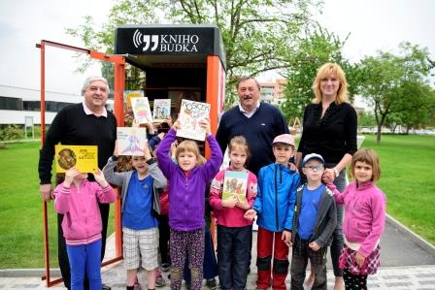
Karol Dobiaš and Antonín Panenka are the patrons of the BookBooth in Brumlovka Park and were at its grand opening together with children from the Elijáš Maternity School and Ilona Semrádová, the Head Teacher of the Elijáš Maternity School

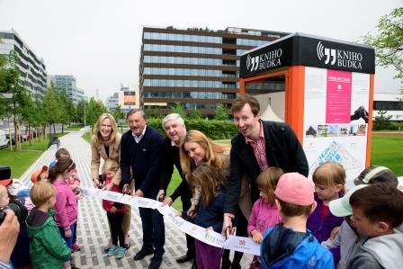
From left: Kristýna Samková, Head of Marketing and PR from PASSERINVEST GROUP, Antonín Panenka, Karol Dobiaš, Jana Šormová, Director of non-profit organisation Krása pomoci, and Pavel Železný, co-author of BookBooth project, cut the tape together with children from the Elijáš Maternity School

For more information and photographs in print quality please contact:

Kristýna Samková, Head of Marketing and PR
PASSERINVEST GROUP, a.s.
Tel.: (+420) 221 582 111, fax: (+420) 222 515 521
Mobil: (+420) 602 186 708
E-mail: Kristyna.Samkova@Passerinvest.cz
www.passerinvest.cz, www.bbcentrum.cz

Marcela Štefcová
Crest Communications a.s.
Tel.: (+420) 222 927 125
Mobile: (+420) 731 613 669
E-mail: marcela.stefcova@crestcom.cz
www.crestcom.cz

ABOUT THE DEVELOPER

PASSERINVEST GROUP, a. s., is a purely Czech development company, whose name is primarily connected with the construction of the multifunctional BB Centrum complex in Prague 4 – Michle. The company, founded in 1991 by Radim Passer, built a very good name on both a domestic and international level with this, the most successful and extensive Czech project of its kind. This is not only due to the quality of the implemented projects and the high level of provided services, but also to a sense of fair play, an accommodating relationship with the tenants/users of the buildings and the responsibility towards society and the environment. PASSERINVEST GROUP also has other interesting development projects in its portfolio.

ABOUT THE BOOKBOOTH PROJECT
The non-profit BookBooth project originated in 2013 as a volunteer activity of Monika Serbusová and Pavel Železný. The goal is to create a free public library by converting old phone booths. At the current time it works on the principle of sponsorship/adoption, where the BookBooth team, after coming to an agreement with the sponsor, reconstructs an old booth in various styles and designs or remotely helps another team of volunteers with the modification and implementation. The logo and text of the BookBooth’s sponsor or adopter is always placed on one side of the booth and on the other side there is space for the free presentation of a local non-profit organisation.

